**The charts below show the main methods of transportation for people travelling to one university for work or study in 2004 and 2009.**

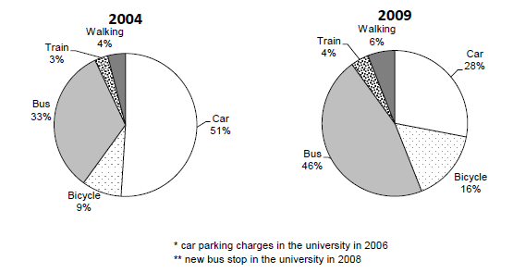

**\*Car parking changes at university in 2006**

**\*New bus stop at university from 2008**

______________________________________________________________________________________________________________________________________________________________________________________________________________________________________________________________________________________________________________________________________________________________________________________________________________________________________________________________________________________________________________________________________________________________________________________________________________________________________________________________________________________________________________________________________________________________________________________________________________________________________________________________________________________________________________________________________________________________________________________________________________________________________________________________________________________________________________________________________________________________________________________________________________________________________________________________________________________________________________________________________________________________________________________________________________________________________________________________________________________________________________________________________________________________________________________________________________________________________________________________________________________________________________________________________________________________________________________________________________________________________________________________________________________________________________________________________________________________________________________________________________________________________________________________________________________________________________________________________________________________________________________________________________________________________________________________________________________________________________________________________________________________________________________________________________________________________________________________________________________________________________________________________________________________________________________________________________________________________________________________________________________________________________________________________________________________________________________________________________________________________________________________________________________________________________________________________